**Mid Compensate Assignment**

Name: Md Farhan Ishmam

Student ID: 180041120

Section: CSE-A

Program: B.Sc. Engg. CSE

Department: CSE

Table of Contents

**SPEC Benchmark3**

SPEC Benchmark Suites6

Evolution of SPEC Benchmark Suites10

SPEC Tools11

Benchmark Program12

Portability13

License14

SPEC CPU15

SPEC Cloud 18

SPEC Workstation19

SPEC Organization21

Conclusion22

References22

**Point to Point Interconnection (QPI)23**

Derivatives of P2P Interconnection23

Characteristics of QPI25

QPI Architecture26

Implementation28

Multicore Configuration Diagram29

QPI All Layer’s Protocols31

Conclusion33

References34

Spec Benchmark

Back in the early days of computers, comparing computer devices was relatively easier. The computers of earlier generation were much simpler compared to computers of modern generation. By easily comparing a handful of factors, a person could have determined which one is the more powerful computer. But now, there the number of factors related to performance is more than a handful. Maybe in the early days, in order to evaluate the performance of a computer, the person had to know about the CPU clock speed, number of instructions per second (IPS), amount of RAM and storage capacity. There might be a handful of other factors involved but they don’t change the magnitude of performance quite drastically. But modern computers have grown far more complex. The machines have more factors involved and even the components like CPU, storage etc. have become more intricate. Let’s take the CPU for instance. Maybe, back in the early days of computing, knowing the clock speed and instructions per second was enough to determine how good the CPU will perform. But now CPU has been optimized with cache which can take up to 3 levels, the number of cores and threads, bandwidth of CPU bus (address, data, control) architecture of CPU, and so on. Even these factors depend on other factors, like the cooling of the CPU (if the CPU can be cooled quickly then it will give better performance). It has become so complex that even comparing CPUs from the same product family, say CPU ‘A’ from AMD Rhyzen family has 3.4 GHz and CPU ‘B’ has a clock speed of 2.9 GHz with the same number of cores. But still can’t conclude that CPU ‘A’ is faster the ‘B’. CPU ‘B’ might be from a later generation and has better architecture (Rhyzen CPUs usually have a 15% IPS increase generation to generation) or has more cache or threads. In these cases, there is a possibility of CPU ‘B’ to outperform CPU ‘A’ even though CPU ‘A’ has more clock speed. So, it’s safe to say that the whole computer system is far more complicated and it’s impossible to make a performance assessment based on the hardware specifications only.

If we think about the assessment of a computer, we will realize that we, as end-users, don’t care about the hardware specifications as long as we can get decent performance from our software. That is why programs like benchmarks are introduced which will evaluate the end-performance of the computer as a whole.

Traditionally, software was first used to determine the performance of a single component or a type of action. We can say that the number of instructions per second is a component-level performance which can help as assess the performance since higher IPS will make the performance better. Benchmark software were developed which made an amalgamation of the results of component level performance of each component of the CPU. Later synthetic benchmarks were developed which used repeated procedures for assessment but with minimal bottleneck among the components. For example – Super PI is a lightweight synthetic benchmark software which calculates the digits of pi by running a same algorithmic procedure over and over again. These kinds of benchmarks can be used to assess certain aspects of the performance but we need to keep in mind that our daily life computer programs do not use a single procedure like this. Furthermore, the potential bottlenecks can cause a significant difference in performance.

To tackle the previously mentioned problems, real-life or real-program benchmark was introduced which will run programs similar to the ones we use in our daily life. SPEC or Standard Performance Evaluation Corporation is a company which provides such benchmark programs for computer performance assessment. Some programs are executed and based on the performance some data is generated. Generally, for these scores, the higher number is better. This score is created relatively to a reference machine. SPEC offers individual benchmarks typically in the form of a collection known as SPEC Benchmark Suites and these suites are packaged together to make the complete benchmarking program.

SPEC Benchmark Suites

Spec Benchmark Suites are simply sets of programs packaged together to test a particular type of task performed by the computer. The most popular among such suites are the SPEC CPU Benchmark Suites. SPEC CPU suites are comprised of Integer calculation programs, Floating-point calculation programs, C-compilation using GCC and so on. A score is produced based on the performance of each individual suite relative to a reference machine. Geometric mean is performed on these individual relative scores to produce an overall score which would be the CPU assessment score for that device. Each suite is comprised of a variety of programs made to perform a single task. For example – the floating-point precision for SPEC CPU has different individual programs (17 of them in CPU2006) to evaluate the same task which is to perform floating point calculations and measure the time taken to do such tasks. The programs are run multiple times to get a precise and accurate result. All these things made SPEC CPU benchmarking an industry standard program. The latest release of SPEC CPU is SPEC CPU 2017 which is still getting support from SPEC while the previous releases have been discontinued.

SPEC also provides benchmarking suites for Java client and server-based performance evaluation. SPECjvm is popular for Java Virtual Machine (JVM) evaluation where the software and hardware performance are evaluated. Other benchmarking suites related to Java include JBB or Java Business Benchmark which is intended for machines in business-enterprise levels and emulates a three-tier system. Other business-related factors and logics are involved to create a proper replica of running Java programs in the industry standard. In this way the performance of a computer while running a Java application is evaluated. jEnterprise is used for the assessment of the Java 2 Enterprise Edition (J2EE) and also implements a multi-tiered system focused mostly on business and industry grade evaluation of such J2EE applications.

SPEC also introduced suites for storage, power, web servers, mail servers, virtualization and high-performance computing. Among them web servers, mail servers and high-performance computing (HPC) has been discontinued while virtualization has gained a lot popularity recently. SPECvirt is the suite used for evaluating the capability of a computer to create a virtual environment or system (for instance – creating a virtual system of Windows XP with lower allocated resources and using it on a Windows 10 desktop). The storage suite SPEC SFS measures the file server throughput along with response time for storage devices and storage services. SPEC SFS assessment is a standard method for storage evaluation and supports both Network File System and Server Message Block protocol access. SPECpower provides similar services for power supply evaluation. SPEC also provides a wide range of programs for workstation performance and doing graphics-intensive work load. These suites include GPU-intensive rendering programing and generating 3D environments. Usually, compilation time of doing such tasks is used to evaluate the performance; here, lower time means better performance. The benchmark suites include SPECapc, SPECviewperf and SPECwpc. SPECapc has subdivisions for Maya, SolidWorks, 3ds Max and other 3D modelling & rendering applications.

Among the SPEC Java client and server suites, JVM was introduced earliest with SPECjvm98. The latest version of JVM benchmark suite is SPECjvm2008 and is still being supported. For jAppServer SPECjAppServer 2001 was introduced which later got replaced a year later with the 2002 version. The final release was SPECjAppServer 2004 but it got discontinued later on. SPECjbb2000 was the first version for JBB server with SPECjbb2015 being the latest version still gaining support. Two versions 2005 and 2013 were released and discontinued. The jEnterprise has been introduced in 2010 with SPECjEnterprise 2010. It is still supported by SPEC along with their latest release of SPECjEnterprise2018. For JMS, SPECjms2007 was introduced which is still currently being supported.

There were 3 active mail server assessment benchmarking suites with SPECmail2001 being the first one, followed by SPECmail2008 and SPECmail2009. However, mail server technology started losing popularity and all these three suites were discontinued.

SPEC SFS2014 is used for storage and is still supported. The storage benchmark suites were introduced at SPEC_SFS93 also known as LADDIS. The 2.0 and 3.0 versions were introduced later on being labeled as SPEC SFS97 and SPEC SFS97_R1 respectively. Later SPECsfs2008 replaced these versions. For power benchmarking, SPECpower_ssj 2008 is being used and is supported till date.

Web servers are also products of the past and the SPEC web server benchmarking has been discontinued with the latest version being SPEC web2009. Modern day web server technology has widely changed and the old static style of webpages have quickly been replaced with dynamic ones. The evolution of webserver benchmarking started with SPECweb96 followed by SPECweb99, SPECweb99_SSL and SPECweb2005.

Virtualization is one of the latest fields of assessment. With SPECvirt_sc2013 still being supported as the current benchmark suite for SPEC. It is shortly known as SPECvirt. SPECvirt_sc2010 was the first product in this lineup which stopped receiving support from 2014.

The latest benchmarking suite is that of Cloud IaaS. Resources of IaaS cloud platforms are evaluated using this benchmark. SPEC introduced SPEC Cloud IaaS in 2016. With the sudden boom of cloud computing technology, shortly after that SPEC Cloud IaaS 2018 was introduced. Both versions are still getting support from SPEC.

Over the time, SPEC has broadened the range of evaluation from basic computer components like CPU to wide-ranged technologies like cloud IaaS. SPEC suites have integrated more varieties of programs for accurate performance assessment and the previous versions of the individual programs in each suite were also replaced with more accurate and efficient versions.

Evolution of SPEC Benchmark suites

It can be clearly understood that the tasks revolving around a computer system is quite complex and it nearly impossible for a single program to evaluate the whole component and characterize the performance of our device. But for the convenience of the users a single number or score is required for them to draw quick conclusions regarding the computer or the computer system. The benchmarking also needs to be standardized and consistent. SPEC started working on this idealistic benchmark program and tried to develop programs which can virtualize real life application-based scenarios as close as possible. The comparison had to be more than one dimensional and has to be spread across the whole computer system utilizing the potential of each of the components and internal structure including the architecture, memory system, the input-output system along with the peripherals of the computer. Additional problems regarding variety in operating system, networking options, graphics utilization were also considered. SPEC concluded that the CPU performance could have been simplified to the integer and floating-point calculations performed by the CPU for a wide range of algorithms using different libraries and compilers. However, there were still more variables involved and SPEC needs to standardize their scores. In the upcoming months, the conflicts regarding portability were resolved and SPEC developed a method to perform standardization. The programs were run in the machine and simple form of unit, like time required to execute the whole program, was used to evaluate and the time was compared with that of a reference machine. Ideally, the DEC VAX 780 was chosen as the reference machine. Sets of data were produced as the ratio of the score between the performance in the original machine and the reference machine. The score ratio had to be then converted to a single score. There was a dispute among the experts regarding this issue. Some of them seemed to favor weighted arithmetic scores while the other group favored the geometric mean. But later on, it was decided that the geometric mean which would also act as a composite metric would be used to make an amalgamation or mean of the individual ratios. It was also favored since the difficulty of weighting each program individually was removed and it would work better as a philosophy of evaluation for the long term. All the suites in the release 1 of SPEC CPU were derived using geometric mean.

SPEC Tools

SPEC is also offering a range of tools starting from server efficiency rating to power measurement components. Server Efficiency Rating Tool, also known as SERT, was developed for measuring server efficiency. The tool was intended to be used as a part of 2nd generation of Environmental Protection Agency (EPA) of US. SPEC Chauffeur WDK Tool was made for simplification of workload development to efficiency in using energy and enhanced performance. PTDaemon software from SPEC was designed to control the power analyzing components in benchmarking related to measuring power.

Benchmark Program

So far we have looked at the suites and how SPEC evolved those suites with the passage of time. Benchmark program is just an amalgamation of various suites packed together to evaluate a component, system or system of components. SPEC CPU2017 is an example of a Benchmark Program. There are other benchmark programs from vendors other that SPEC, for example – Speccy, CineBench, CPU-Z and so on. These programs are not usually aimed at industry standards and usually used by casual enthusiasts around the globe. While some of that like CineBench and RealBench are quite popular for the assessment of graphics-based work.

SPEC CPU is now the industry standard for CPU assessment. A more descriptive analysis of SPEC CPU is done later in the assignment. But the other programs are also widely used, especially the Java Enterprise and Java Virtual Machine suites, SPEC workstations suites, Storage suite, Power suite, along with the latest suites on Virtualization and Cloud IaaS. SPEC also introduced the CPU search program known as SPEC CPUv6 for locating software that can be used in CPU benchmarking suites but it has been discontinued. Other that, SPEC also programs for graphics based and high-performance computing which weren’t mentioned before. Such program includes SPECapc, SPEC HPC (discontinued), SPEC OMP, SPEC MPI and SPEC ACCEL. Overall, we now have a general idea about all the benchmarking programs by SPEC.

Portability

Before we dive deep into the portability of SPEC benchmarking programs, we must first have a clear concept on portability. Let’s say someone wrote a code in C which has been compiled and executed in a certain computer. If the program is copied and executed on another machine then will it work? The answer actually varies. In the early days of computers, this wouldn’t have worked. Because computers used to differ vastly internally. But now computers follow the same architecture. So, if the application can run on Windows 10 in PC ‘A’ then it will also run on PC ‘B’ if it also used Windows 10. But if it uses Linux or other OS then it might not run. A (.exe) file is executable for the windows family of operating systems. Other OS have different form of executable. Again, a program from Windows 10 won’t likely run on Windows XP. Forward compatibility is not always ensured but in many cases backwards compatibility is ensured. This brings us the concept of portability which focuses on the philosophy – write once, run anywhere. Portability ensures that the same code doesn’t need to be rewritten for different platforms.

SPEC benchmarking programs have also been written in languages which are portable. This includes C which is used to write majority of the SPEC programs but also includes C#, FORTRAN and Java. The codes are compiled in different platforms and thus desired programs can be executed in any platform as long as the platform can provide the compiler. Further enhancements were done to these benchmarking programs to improve performance but SPEC has restricted and put limits on such optimizations with their rules. In short, we can say that SPEC benchmark programs have great portability.

License

Programs can’t be used for free. Even though SPEC is a non-profit organization, it needs capital for the development of its latter releasing and for supporting the current releases. The SPEC licensing varies a lot depending on the range of the performed test. But it is usually bounded with a several hundred dollars but can go as high as to several thousands of dollars. SPEC uses a pay-for-license model and even though some of these benchmarking suites use GCC licensed by GPL or general public license, this doesn’t invalidate the type of licensing used by SPEC since the license of GPL ensures that products of GPL have free distribution but derivatives from their product doesn’t necessarily need to follow the same steps.

SPEC CPU

The SPEC CPU product lineup was introduced as the previous generation of benchmarking software faced difficulties in ensuring proper, consistent and accurate form of evaluating the CPU. They included problems like smaller programs which can be easily cached, single number performance, instruction amalgamation which carries obsolete instructions and are rarely used my modern software, inconsistent results, short runtime and so on. With the introduction of SPEC release 1, SPEC used 10 different programs to tackles all the issues of individual benchmarking programs. The programs included 4 integer calculation and 6 floating point calculation and ranged among a wide array of tasks including C compilation using GUN, LISP interpretation, Matrix solution, Mesh generation, PLA optimization and so on. One of the floating-point programs known as 013.spice2g6 was used for double precision floating point benchmarking and ran the task of circuit simulation and circuit analysis for assessment. The following table contains the information regarding the benchmarks used in the SPEC release 1 suite.

In the next table we can see the number of programs used for Integer and Floating-points specifically. The company announced their first product on 1989 also known as SPEC release 1 which essentially acts as a CPU benchmark suite. CPU89 was comprised of SPECint89, SPECfp89 and SPECmark89 for integer, floating point-based calculations and composite calculations.

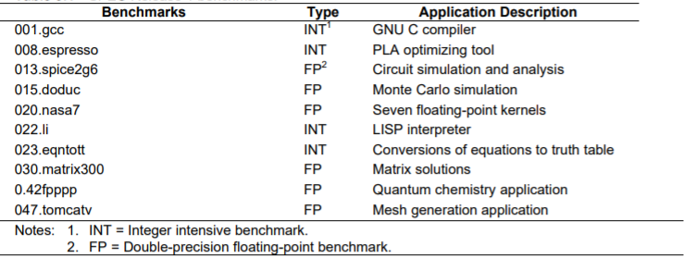

Source - Overview of the SPEC Benchmarks by Kaivalya M. Dixit

There were only 4 such programs in SPECint89 and 6 in SPECfp89 and the numbers increased gradually over the coming years. After CPU89, SPEC released 5 more CPU suites and each suite increased the number of programs than its predecessor. The latter suites of integer and floating points are referred as CINT and CFP. To get an idea of the integer programs with in this suite, we can examine the CINT92 which comprises of 6 individual programs – 008.espresso, 022.li, 023.eqntott, 026.compress, 072.sc, 085.gcc. Here the programs work for logical array optimization, LISP interpretation, truth-table equation conversion, compressing texts, spreadsheets and GNU compilations. These individual programs are replaced version to version. For instance, the first 3 benchmarks are from release 1 but the latter 3 are added in the CINT92. The 001.gcc is replaced by the 085.gcc in the CINT92 which takes considerably lower time. In total over 17000 instructions are executed in the CINT92 program and the number of instructions executed has been increased considerably in the latter versions. CPU92 also introduced two new suites SPECrate_int92 and SPECrate_fp92 to evaluate using throughput.

The latest version of the SPEC CPU is SPEC CPU2017 which comprises of 4 suites - SPECspeed 2017 Integer & Floating-Point suites along with SPECrate 2017 Integer and Floating-Point suites. The first set measures in time comparison while the second set measures in throughput.

The table shows the number of programs used in the previous versions of SPEC CPU:

|  |  |  |  |  |  |
| --- | --- | --- | --- | --- | --- |
|  | CPU89 | CPU92 | CPU95 | CPU2000 | CPU2006 |
| Integer programs | 4 | 6 | 8 | 12 | 12 |
| Floating -point programs | 6 | 14 | 10 | 14 | 17 |

Source - Benchmarking by Reinhold Weicker

The instruction profile of SPEC CPU releases has also differed vastly version to version. The instructions can generally be classified as memory-based instructions like loading or storing, branching, floating point instructions and so on. The CINT92 suite had 27.3% memory-based instructions and 23.3% related to branching among 17 billion instructions executed by the suite. While the floating-point suite shared a much higher rate of memory-based instructions at 33.2%, along with 27.2% for floating point operations and 6.5% for branching. In total 93 billion instructions were carried out by CFP92. The latter releases had an increase in instruction count and the percentages also differ drastically.

SPEC Cloud

The latest addition to SPEC’s performance evaluation suite are the Cloud IaaS suites which will evaluate the computational power and storage capacity of cloud-based infrastructure as a service (IaaS). As cloud-based technology is relatively new and grew immense popularity recently, the service was introduced in 2016. Before diving deep into the assessment of cloud computing, let’s have a lot at what cloud computing actually is. The machines we usually use are physical machines located right in front of us. The machines are interacted physically using the buttons of our keyboards or maybe mouse-clicks. But what if there is a machine somewhere far away but is allowing me to access the resources of that machine. If we interact with those virtual machines through networking means then it is possible to use that virtual machine just like our physical machine to perform our required tasks. Such a concept is used in cloud computing. Infrastructure as service is methodology of cloud computing which can be used to access virtualized resources and the internet will be used as the medium of connection. It is one of the three main categorizes of cloud computing service; the other two being software as a service and platform as a service.

Using IaaS, we can now have access to a virtual computer. But how do we evaluate this virtualized machine? The machine will provide us resources like computational resources or the CPU power, memory, storage and networking resources. These criteria are assessed by the SPEC Cloud IaaS which was introduced with SPEC Cloud IaaS 2016 and the latest release of this suite is SPEC Cloud IaaS 2018.

These programs don’t work exactly like their non-virtualized counterparts. The emphasis on internal architecture along with the power consumption, longevity and reliability of the machine or the pricing metrics. While more focus is given on network and provisional resources, a lot of flexibility is given while setting up CPU, main memory, secondary memory and other stuff which can be combination of physical and virtual parts. The cloud computing network must also consist of at least three physical servers. The main method of performance assessment is done by putting a workload by creating instances (application instances for example) in the cloud computer network and derives a ratio with its own reference scores.

SPEC Workstation:

SPEC Workstation was introduced to make assessments of computer devices used in workstations which usually includes graphics intensive tasks on APIs like OpenGL and also various types of rendering tests. SPECviewperf, SPECwpc and SPECapc are the three suites used for such evaluations with their latest releases being SPECviewperf13 and SPECwpc v2.1 for SPECviewperf and SPECwpc respectively. SPECapc has different versions depending on its own 3D modelling software. Such software includes PTC Creo, SolildWorks, 3ds Max, Maya, and Siemens NX. The SPEC workstation3 benchmark is a suite made for evaluation of all key aspects of the assessment which can be used for machines beyond the ones used by consumers. For instance, it can support more than 64 logical cores and non-consumer end graphics cards interconnected with SLI and their own decoding units. The benchmark program runs at least 30 workloads comprising of nearly 140 tests. The workloads range from a wide variety of tasks including GPU computation, 3D animation, 3D rendering, CAD/CAM and so on. The individual scores usually follow the rule of thumb – higher is better and are then compared to the reference machine. The latest releases use the Z240 tower reference machine with server grade Intel E3-1240 processor, Radeon Pro Graphics and 16 GB of main memory. The individual benchmarking programs can usually be categorized in Blender, Handbrake, LuxRender, Maya and 3ds Max for graphics evaluation. Programs are also used for product development, life science, medical, oil and gas related services, financial services. GPU computation is also done using LuxRender, Caffe and Folding@Home. In this way a proper assessment can be developed by evaluating across a wide range of programs from different fields for the workstations.

All the releases of SPEC workstation suites are shown below:

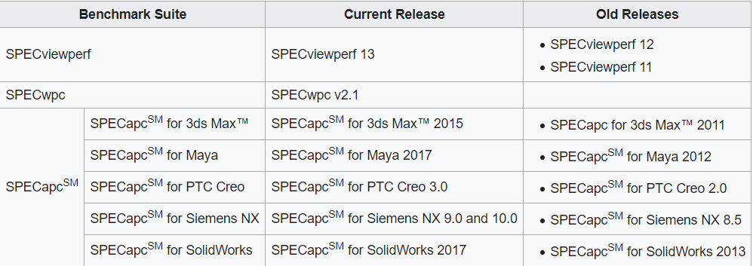Source – Wikipedia

SPEC organization

Finally, in the last part of this assignment, we will discuss of SPEC as an organization and all the intricacies related to this organization. It has been only a little more than 30 years since SPEC being formed in October of 1988. But the company has grown drastically in the upcoming years and is still a renowned name in the industry of benchmarking. SPEC claims to be a non-profit organization but involved in license charges for the development and support of their benchmark releases. Now, SPEC is comprised of more than 60 member companies which include big names like Intel Corporation, Sun Microsystems, IBM Corporations, AT&T, Hewlett-Packard (HP) Company and so on. The company is subdivided into 4 diverse groups which are – Open Systems Group (OSG), High Performance Group (HPG), Graphics and Workstation Performance Group (GWPG) and the latest addition, the Research Group (RG). The original group being the Open Systems Group includes sub-groups on Cloud, CPU, Java, Power, Storage and Virtualization. The high-performance group targets standardized benchmarking for large-scale computer systems, workstation clusters, vector parallel supercomputers and distributed memory parallel systems. The Graphics and Workstation Performance Group is working on projects like SPECapc, SPECgpc and SPECwpc. SPEC research group facilitates research and development regarding the upcoming technologies and improving their previous releases. This group is also in charge of collaborating with universities and ensuring academics involvement from non-professionals in supporting the research of SPEC.

Conclusion:

SPEC has been revolutionary in providing benchmarking programs from casual enthusiasts to professionals of big corporations. The field of benchmarking has changed drastically in the previous years and it is still too early to predict the turnout in the coming years. Till then SPEC is continuing to innovate and ensure precise and consistent benchmarking in all the new and coming fields of technologies along with polishing and supporting their older releases.

*References –*

1. *Benchmarks as Fast As Possible -* [*https://www.youtube.com/watch?v=cHtNJngtS1I*](https://www.youtube.com/watch?v=cHtNJngtS1I)
2. *Wikipedia Standard Performance Evaluation Corporation -* [*https://en.wikipedia.org/wiki/Standard_Performance_Evaluation_Corporation*](https://en.wikipedia.org/wiki/Standard_Performance_Evaluation_Corporation)
3. *Overview of the SPEC Benchmarks by Kaivalya M.Dixit -* [*http://jimgray.azurewebsites.net/benchmarkhandbook/chapter9.pdf*](http://jimgray.azurewebsites.net/benchmarkhandbook/chapter9.pdf)
4. *SPEC official website –* [*https://www.spec.org/benchmarks.html*](https://www.spec.org/benchmarks.html)
5. *Benchmarking by Reinhold Weicker -* [*https://link.springer.com/content/pdf/10.1007%2F3-540-45798-4_9.pdf*](https://link.springer.com/content/pdf/10.1007%2F3-540-45798-4_9.pdf)

Point to Point Interconnection (QPI):

Our computer contains a set of components bound together and it has to communicate continuously with these components. A computer doesn’t act like a single component device; it’s more like a complex system with many components and sub-systems. Now, for our typical computer system we can generalize these sub-systems as the CPU, memory, storage, input-output devices and so on. To have a better performance we need to ensure that the communication between these components can be done as rapidly as possible, so that there is no delay while transferring the signals. The system of computer component connections which deals with the internal communication among the components of a computer’s internal system is called interconnection.

Derivate of P2P interconnection

Computer Interconnection heavily relied on bus-based interconnection for many years. In this case each and every component has to share a single simple bus which is comprised of three lines – control lines, address lines and data lines. So, for example, if the CPU has to interact with the memory, then it has to use this system bus and again if it needs to interact with the I/O devices then the same bus will be used. As we can guess from this design that the shared will always have a lot of traffic ongoing. To tackle this problem multiple solutions were proposed which includes multiple-bus interconnection through hierarchies. But the most prominent design was point to point interconnection – an approach taken by Intel’s Quick Path Interconnect (QPI). This technology was first introduced in 2008 and has gained popularity in tackling the design issues faced by the shared system bus.

Before diving deeper into point-to-point interconnection let us first look at the limitations of system bus. In bus the data lines are shared by every component of the computer system. As the amount of data transferred started increasing in the upcoming years, the date rate also increased. Bus uses synchronization and arbitration functions but when the data rate was higher there wasn’t enough time to perform these functions. The second biggest drawback was the advent of multicore processing units. As multiple cores needed frequent and quick access between each other it wasn’t possible for a single bus to provide proper interconnectivity among these cores. Point to point connection was able to tackle these problems regarding high data rate, multi-core interconnectivity and low latency. So, we can say the primary constraint was the electrical limitation faced the by the buses to increase the frequency of synchronous buses in order to enable high rate of data transfer while the secondary constraints were regarding the interconnection between multiple cores.

Characteristics of QPI

Primarily QPI needs to have 3 major characteristics which are described below:

1. Multiple direct connections: This ensures the components to access any other component directly. Hence, they need to use the same shared route to access another component. Instead, there a direct unique route which will connect the pair of components together. This also removes the necessity of using arbitration function in bus-based interconnectivity. Let’s have a look an example of this phenomenon. Suppose a computer has 2 cores ‘A’ and ‘B’ with a memory unit and I/O devices. In bus-based system there will be single connection shared by all these components. On the other hand, QPI must ensure connection between ‘A’ to ‘B’, ‘A’ to memory unit, ‘B’ to memory unit, ‘A’ to I/O, ‘B’ to I/O and I/O to memory unit (for direct memory access).
2. Layered protocol architecture: Ordinary system buses use control signals only. But the QPI need a layered protocol architecture which can be similar to the networking layered protocols like TCP/IP. Layer to layer connectivity is ensured. QPI generally uses a four-layered architecture.
3. Packetized Data Transfer: As the name implies the data are packaged together into small packets and are set as a sequence of these packets. Unlike bus interconnectivity where raw data is sent, in QPI the data packets are quantized and has advantages in controlling the access of data and ensuring better reliability. The data packets include control headers and error control codes.

QPI architecture:

The QPI architecture is comprised of four layers. However, some devices use an additional transport layer which is generally not needed for most implementation including Core i7. The Physical Layer is the lowest level of this system which ensures the physical transfer of data through actual bits of zero and ones. The link layer ensures data flow and transmission. Routing builds up the framework necessary for directing the data packets though the interconnected components. Finally, the protocol layer ensures data transfer through packets and other function related to transfer like cache coherence. These layers are explained in details later on.

The following figure shows the general layout of the protocol layers in a QPI interconnection. Transport layer is also shows as it is present in different implementations of QPI and Intel officially recognizes it as part of the protocol.

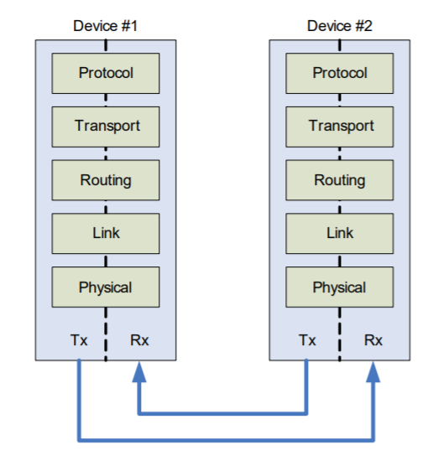

Fig – QPI layered architecture

Source - An Introduction to the Intel® QuickPath Interconnect by Intel

Implementation:

QPI is just part of a whole system of implementations which Intel calls quick path technology. In the simplest form of the implementation of QPI, we can visualize a single QPI interconnected to the processor and I/O Hub. Let’s look at this instance where the processing units are all interconnected and each processing unit can also have access to its I/O Hub. This sort of arrangements is seen in the given figures. We can see two, four and eight cores in the processing unit and the QPI grants interconnectivity to all these cores. There should be integrated memory controllers which enable non-uniform memory access architecture. It is also to be noted that each core has direct access to its own set of DRAM and also to the I/O Hub. The same system can be implemented for more cores like 8, 16, 32 and so on. The physical layer implementations can also differ in the quadrants where each quadrant can be used independently to ensure reliability.

Multicore configuration Diagram:

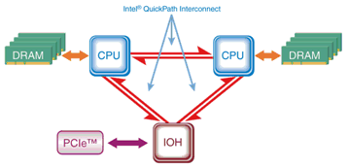

Fig 1 - 2 Core interconnectivity using QPI

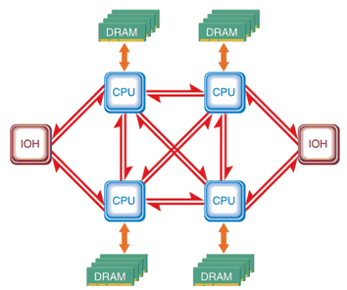

Fig 2 - 4 Core interconnectivity using QPI

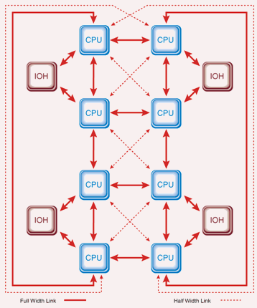

Fig 3 - 8 Core interconnectivity using QPI

Source - The Essentials of the Intel QuickPath Interconnect Electrical Architecture By Dave Coleman and Michael Mirmak

From the diagrams of multicore implementation, we can tell that each core is interconnected to using QPI which is the major difference in the architectural implementation of QPI with bus-based connectivity.

QPI All Layer’s protocols:

The description of every layer is given below:

1. **Physical Layer:** The lowest and the closest to the hardware layer is the physical layer which is actually comprised of real-wiring and circuitry carrying all the digital signals around the components. It also comprises all the necessary logic devices related to processing these signals. The unit of data transfer in physical later is “phit” which means physical unit. Usually a 20-bit phit is used. The phit is transferred using a data lane which consists of a pair of wire and ensures transfer of a single data bit at a time. That means there must be 20 lanes available along with a clock lane for each direction. So, QPI can transfer up to 20 bits in a single direction. The link signal speed is usually around 6.4 GT/s or 6.4 billion transfers per second. With the 20-bit transfer rate we can see that a single directional transfer can be up to 16 GB/s and considering the fact that QPI is bidirectional it can double up to 32 GB/s. The lanes are usually grouped into quadrants, i.e., there will be five lanes in each quadrant. The methodology used in data transfer in the physical layer is referred as the differential signaling or balanced transmission which means that a single line will have the positive voltage while the other line will have zero voltage. As the positive voltage is really low it is often referred as low voltage differential signaling (LVDS). Another function called multilane distribution is also used.

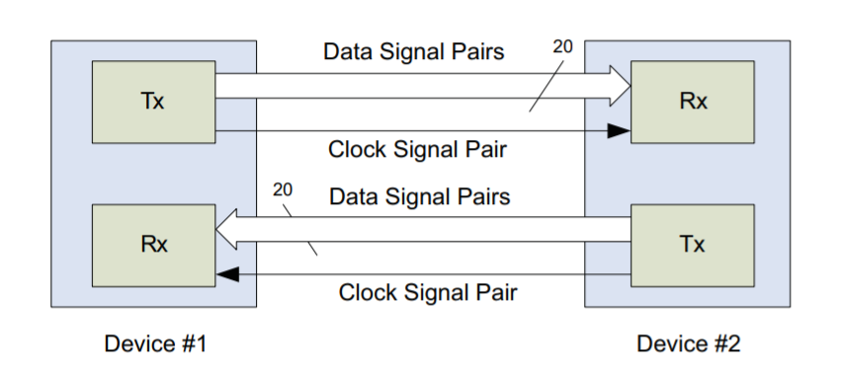

Fig. Physical Layer of QPI

Source - An Introduction to the Intel® QuickPath Interconnect by Intel

1. **Link layer:** Primarily two functions need to be performed by the link layer which are flow control and error control. The data needs to transfer at a particular rate, excess of data transfer has to be prevented. This control of data flow is done by the flow control which ensures that the receiver doesn’t get overflowed by data and is also responsible for clearing the data buffers. There is a credit counter which is used to control the pace of data transmission and this proper data flow is ensured. Error control function does what the name implies, the changed data in physical layer is to be detected and recovered. Often due to noise and other factors, the error signals in physical layer gets changed and it is the responsibility of error control function to ensure retrieval of accurate data. It also ensures the fact that the higher layers don’t have to deal with erroneous data.
2. **Routing Layer:** The course of the packet transfer is determined by this layer. It uses a unit comprised of 72 bits with the header taking 8 bits and the payload taking 64 bits. The header will contain the type of message along with the destination. The routing tables are examined when a unit reaches the destination. The routing would be simple for a device with a single QPI but the tables get more and more complicated as the system becomes larger.
3. **Protocol Layer**: The final layer of the QPI architecture where data transfer is done in packets. Usually, a memory cache row or block can be called a packet. Another important function of this layer is the cache coherency protocol which makes sure that the multiple caches are consistent.

Conclusion:

The field of technology is revolutionary. Old designs are replaced by new ones within years as necessity arises. QPI is an example of such a technology born from necessity. Technology keeps changing rapidly and we won’t be surprised if we find QPI getting replaced in the coming years.

*References –*

1. *An Introduction to the Intel® QuickPath Interconnect by Intel -*

*https://www.intel.com/content/www/us/en/io/quickpath-technology/quick-path-interconnect-introduction-paper.html*

1. *The Intel QuickPath Interconnect Architecture*

*By Robert A. Maddox, Gurbir Singh, Robert J. Safranek – https://www.drdobbs.com/parallel/the-intel-quickpath-interconnect-archite/217500801?pgno=3*

1. *Intel QuickPath Interconnect – Wikipedia*

*https://en.wikipedia.org/wiki/Intel_QuickPath_Interconnect*

1. *Computer Organization and Architecture by William Stallings*